Section 1 — Introduction
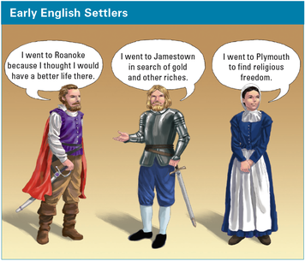

In Chapter 5, you read about eight European explorers who came to the Americas. In this chapter, you will learn about three groups of English people who came to settle there. They made the hard voyage across the Atlantic Ocean. Then they built small communities, or settlements[settlement: a small community that is started in a new place]. They faced many challenges.
Roanoke[Roanoke: the name of the island where the first English settlement was started in North America in 1587. Roanoke is located near the coast of present-day North Carolina.] was the first English settlement. Roanoke is an island off the coast of North Carolina. No one knows what happened to the settlers there. Few signs of them remained when ships came to find them. That is why, today, Roanoke is called the “lost colony.”
Shortly after the attempt to settle Roanoke, 105 Englishmen arrived in present-day Virginia. They hoped to find gold and other riches. They began a settlement called Jamestown[Jamestown: the first successful English colony in North America, it was founded in 1607 in present-day Virginia] in 1607. Despite many hardships, Jamestown became the first successful English colony in North America.
A few years later, 102 English people arrived in present-day New England. They built a settlement called Plymouth[Plymouth: a town started in 1620 by early English settlers called Pilgrims. Plymouth is located in present-day Massachusetts.], in what is now Massachusetts. Most of these people left England to seek religious freedom. They became known as the Pilgrims. Pilgrims are people who go on a religious journey.
As you read this chapter, think about the hardships faced by these three groups of English settlers. Why did some settlements survive, while others did not?

Section 2 — The Lost Settlement of Roanoke
In the 1500s, Spain was a powerful nation. Its ships sailed to the Spanish colonies in the Americas. They brought back riches to Spain.
Sir Walter Raleigh was a friend of England’s Queen Elizabeth. He believed that American colonies could make England more powerful. In 1584, he sent two ships to explore the coast of North America.
The ships landed on an island near present-day North Carolina. The sailors named the island Roanoke, for the American Indians who lived there. The explorers returned to England. They told Raleigh that the island had fish, animals, fruits, vegetables, and friendly people.
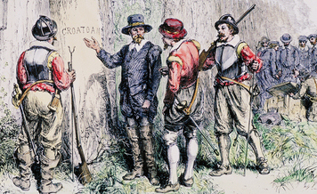
The only clue about what happened to the settlers at Roanoke was the word CROATOAN carved into a gatepost.
The next year, Raleigh sent some men to start a colony. But few of the settlers were farmers. Supplies ran short because the men could not grow food. When fighting broke out between the English and the Roanokes, the settlers gave up and went home.
In 1587, Raleigh sent over 100 new settlers to Roanoke. This time there were farmers and skilled workers. Later that year, Captain John White went back to England for supplies. Because England was fighting a war with Spain, White’s ships were not allowed to return to the colony.
Three years later, White finally returned to Roanoke. There was no sign of the settlers. Even their houses were gone. The word CROATOAN was carved on the gatepost of a ruined fort. White thought the settlers might have moved to the island of Croatoan or joined an American Indian group with that name. Before he could find out, however, the weather turned bad, and he could not search the area. No one has ever discovered what happened to the colony.

Section 3 — Jamestown Colony
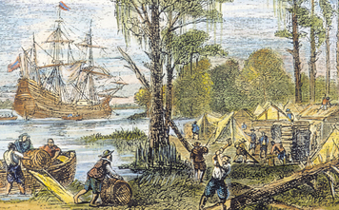
To survive, everyone in Jamestown had to work, even those who were used to having servants.
In 1606, England’s King James gave permission to a group of wealthy men to start a colony in North America. The group sent 105 men to settle in Virginia. They hoped the colony would make them richer.
In May 1607, the settlers arrived in Virginia. Most hoped to find gold. They chose a place near a river. The deep water allowed them to anchor their ships close by. The site was upriver from Chesapeake Bay. It was far enough from the river that Spanish ships could not easily attack the settlement. Located on a peninsula, the town would be easy to defend by land. The group built a settlement enclosed by the walls of a fort. In honor of King James, they called their new home Jamestown.
Unfortunately, the settlers built Jamestown on a marsh[marsh: wet, low-lying land that is poorly drained]. The water around the town was dirty and salty. The land was not good for farming. And mosquitoes carried a deadly disease, malaria. By the end of 1607, disease and other hardships had killed many of the settlers.
In late 1607, some American Indians captured a Jamestown settler named Captain John Smith. They took Smith to their chief, Powhatan (pow-uh-TAN). According to the story Smith later told, the chief was about to kill him. But Powhatan’s young daughter, Pocahontas, saved his life. Many historians, however, think that Smith’s life was never in real danger.
After this incident, Pocahontas visited Jamestown several times. She and her people brought food to trade to the few surviving colonists[colonist: a person who settles in a colony].
In January 1608, more men arrived from England. Many had come only to seek gold, so there were not enough people growing the food needed to feed the colony. In September, John Smith became the leader of the colony. He knew that the settlement needed everyone’s help to survive. He said that any man who would not work to maintain Jamestown would not eat. Smith’s leadership helped save the colony.
In the summer of 1609, a new group of settlers arrived, including women and children. The next month, Smith returned to England after having been badly burned by an explosion of gunpowder. The colonists had lost a strong leader. To make matters worse, Powhatan stopped trading with them. Local tribes attacked the people they found outside the settlement. The winter of 1609–1610 was known as the Starving Time. Many settlers had to eat horses and dogs. Hundreds of people died. Only about 60 settlers survived in Jamestown.
The Jamestown settlers never found gold. Therefore, they needed another way to support their colony. Colonist John Rolfe learned how to grow a new kind of tobacco. The settlers planted this cash crop. In 1614, they began to trade their tobacco for money and supplies. People in England loved it. Tobacco became Virginia’s “gold.”
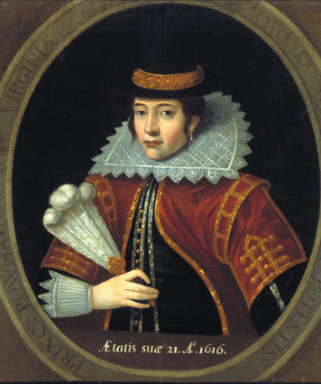
Pocahontas traveled to England with her husband and their young son. While there, she dressed like an Englishwoman. This portrait is based on a drawing made of her during that visit.

Meanwhile, Powhatan’s people worried about so many settlers coming to their land. In 1614, John Rolfe married Pocahontas. For a time, the colonists and the American Indians were at peace. Pocahontas even went to England and met King James. Before she could return home, she became ill. In 1617, she died.
Meanwhile, Jamestown was growing and changing. In 1619, the men elected representatives to make laws for the colony. This was the first representative government in an American colony. They called this governing body the House of Burgesses. (Burgess is an English word for an elected representative.) Only wealthy men could have this job. Even so, Virginia now had a more democratic[democratic: relating to a form of government in which people have the power to rule themselves, often through elected representatives] government than England.
When Powhatan died, his brother became chief and the peace between the American Indians and the settlers ended. In 1622, the new chief and his men attacked Jamestown and killed 347 colonists. But Jamestown survived to become the first successful English settlement in North America.

Section 4 — The Settlement of Plymouth
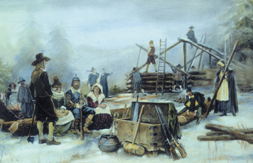
The Pilgrims landed at Plymouth in winter. Almost half of the new settlers died of disease and starvation during the first months.
The third English settlement in North America was started by people who were looking for religious freedom. King James said that everyone in England had to belong to the Church of England. Some people refused. Among them were people called Separatists. This group wanted to have a separate, or independent, church.
The Separatists decided to move to a place where they could be free to practice their own religion. In time, this group came to be known as the Pilgrims.
In September 1620, the Pilgrims sailed from England. They traveled on a ship called the Mayflower. After more than two months at sea, they landed on the tip of Cape Cod in what is now Massachusetts. Before going ashore, the Pilgrims drew up a plan of government. They wrote down rules to help them live together peacefully. Most of the men signed this agreement known as the Mayflower Compact. Then they elected a governor.
After exploring the area, the Pilgrims decided to sail the Mayflower across a bay that separated them from the mainland. They landed at a place they named Plymouth. Soon they began to build houses and a meeting hall called the Common House
The first winter was very hard. The Pilgrims had landed too late in the year to plant crops. The climate was cold and harsh. Nearly half of the 102 Pilgrims died of disease and starvation before spring. Only a few settlers remained healthy enough to care for the others.
In March 1621, a man named Squanto visited the Pilgrims. He was a member of the Pawtuxet tribe but was living with the nearby Wampanoags (wahm-puh-NOH-ags). Some years earlier, Squanto had lived in England and could speak English. Squanto stayed with the Pilgrims and taught them how to plant corn, catch fish, and get sweet syrup from maple trees. The Pilgrims were so grateful that they thought Squanto had been sent by God.
Squanto also told the Pilgrims about the many American Indians who had died from a disease that they had caught from English and French fishermen. While Squanto had been away in England, the members of his Pawtuxet tribe had died from this sickness.
Another American Indian who visited the Pilgrims was Massasoit (MAS-uh-soyt). He was the sachem, or chief, of the Wampanoags. Squanto helped arrange a peace treaty, or agreement, between Massasoit and the Pilgrims. The Wampanoags and the Pilgrims promised not to fight each other. They also agreed to help protect each other against attacks by other American Indians.
The Pilgrims’ corn ripened during the summer. In the fall, they decided to celebrate the harvest—the food they had collected from the plants they had grown. They invited Massasoit to a feast of thanksgiving. He and his people brought deer to cook and eat. The Pilgrims had goose, duck, deer, fish, lobster, and wild turkey. The feast lasted three days. Today, people in the United States still observe this harvest celebration. We call it Thanksgiving Day.
In 1621, William Bradford was elected governor of Plymouth. He held this post for more than 30 years.
In the next few years, ships brought more and more settlers to the colony. In time, other groups would join the Pilgrims in the area we now call New England.

Summary
In this chapter, you read about the first English settlements in North America. You found out why people came to live here. You learned why some settlements survived, while others did not.
The early settlers faced many hardships. One settlement, on the island of Roanoke, disappeared. Another settlement, Jamestown, survived after many bad times. Settlers often did not have enough food. They became sick from unhealthy surroundings. At times, local American Indians helped them. At other times, the settlers and the American Indians fought.
Many settlers were searching for riches. But the Pilgrims hoped to find religious freedom. The Wampanoags helped them survive in Plymouth.
These early settlements were the first of what would become 13 English colonies in North America. How did the American Indians react as more and more people arrived? Read on to find out.

Reading Further — King Philip Decides on War
American Indians and English settlers had a complex relationship. At times, they worked together. At other times, they fought bitterly. As more English settlers arrived, they took lands on which American Indians lived. In 1675, one chief went to war to stop this. How did the English colonies in New England face this challenge?
In the darkness, the people watched as the shadow of Earth slowly moved over the moon. Soon, the great glowing disk was covered completely. Today, we call such an event a lunar eclipse. But the Wampanoag people living in 1675 saw it as a sign: it was time for war.
The eclipse came at a key moment for Metacomet, the son of Massasoit, and his people. Wampanoag relations with the English settlers were badly strained.
It had not always been so. For many years, the Wampanoags had watched as settlers from England moved into their homeland. They had not only tolerated the newcomers but also assisted them. In fact, the settlement at Plymouth might never have survived without the Wampanoags’ help. In 1621, Massasoit had made peace agreements with the leaders of Plymouth Colony. His son, Metacomet, had even taken the English name of Philip. When Philip became the Wampanoag leader, he had hoped to work with the settlers to protect and provide for his people. He also wanted to prevent further English settlement and to organize the local tribes.
But there had been trouble. In 1662, King Philip’s brother had died suddenly. King Philip believed that the English had killed him. Although the Wampanoags continued to work with the English, King Philip’s trust was shaken.
Just a few weeks before the eclipse, the English had put two Wampanoag men to death after finding them guilty of murder. King Philip thought that the men were innocent. He believed that their trial under English laws had been unfair. An angry group of Wampanoag warriors struck back. They killed nine English settlers in a village called Swansea.
King Philip and his people now faced a choice. They could seek peace with the English. Or they could go to war against them.
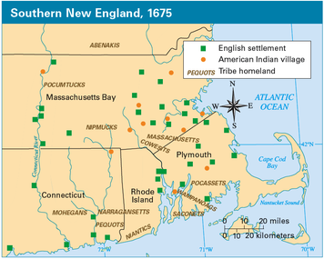

As the Wampanoags pondered this decision on the night of June 26, 1675, the moon slipped into Earth’s shadow. The Wampanoags saw the sign. They knew that much bloodshed would follow. Even so, they decided to fight the English.
King Philip made a fateful choice. The war he began changed the lives of thousands of people across New England. The battles to come were among the deadliest in American history.
King Philip’s War, as it is now known, was a complex struggle. It was not just a war between English settlers and the Wampanoags. New England was home to many other American Indian groups. These included the Nipmucks, the Narragansetts, the Mohegans, and others. Each group faced a hard choice. As one Englishman noted, “Many of the Indians were in a kind of maze, not knowing well what to do.” Some would join King Philip. Others would side with the settlers.
Why were American Indians undecided? Many groups shared King Philip’s anger at the English. But others had friendly ties with settlers. Some had become Christians.
American Indians had fought side by side with English soldiers before. In the Pequot War of 1637, some tribes had joined the English to defeat the Pequot tribe. This war showed that New England’s American Indians were not always friendly with each other. In 1675, deep rivalries still divided many groups. Some would settle old scores by joining the English.
The English settlers were more united than the American Indians. When war broke out, they soon organized to meet King Philip’s challenge. Yet, as with the American Indians, old rivalries and conflicts caused trouble. Communities blamed each other for causing the war. They argued over who would lead and supply troops. Some feared that the war would be an excuse for a rival settlement to take disputed land. Such squabbles harmed English defenses.
At first, the American Indians had success. They surprised the English by making hit-and-run raids. They would sneak up on a target, launch a surprise attack, and then disappear. The English had trouble adjusting to this type of warfare. They wanted to fight in the open.
King Philip’s forces made great gains. Now that victory seemed possible, new allies[allies: one person or nation united with another for a common purpose] joined him. Once-friendly tribes turned against the English. This made the English suspect even loyal American Indians. In one town, officials imprisoned a large group of Christian American Indians on an island in Boston Harbor. Elsewhere, officials tried to take weapons away from American Indians. English commanders refused to use American Indian soldiers in battle. Such treatment turned former friends into enemies.
In the fall of 1675, the English were worried. The mighty Narragansett tribe had not yet joined the war. But the English feared that the tribe might join King Philip. To stop them, the English attacked a large Narragansett settlement. The Great Swamp Fight left many hundreds of Narragansett men, women, and children dead. More than 200 English fighters were also killed or wounded.
The Great Swamp Fight was a terrible blow to the Narragansetts. But it did not stop the American Indian onslaught. Warriors still raided terrified English settlements. In the winter of 1676, villages just 10 miles from Boston came under attack.
As spring approached, the English were on the verge of defeat. Many of their villages lay in ashes. But their fortunes were about to change.
The English did not know that King Philip was in trouble, too. After the Narragansetts’ defeat in the Great Swamp Fight, Philip needed more help. He took a large force to present-day New York. There, he hoped to win the support of the fierce Mohawk tribe. Instead, the Mohawks attacked him. His forces limped back to New England.
At this time, the English made a key decision. They again made use of friendly American Indian soldiers, such as the Christians who had been held on the island.
And they got results. Within months, combined English and American Indian troops were winning the war. King Philip’s forces were on the run.
The end came for King Philip in August 1676. He was shot by an American Indian soldier who had joined with the English. By summer’s end, King Philip’s War was over.
King Philip’s War took little more than a year. Yet its effects were long lasting. A dozen settlements had been destroyed. About 1,000 English settlers in the region, out of a total of about 52,000, had died. The damage to the American Indian population was even worse. Some experts think that as many as 3,000 out of a total of 20,000 American Indians in New England died. Many more were captured and sold as slaves.
When the war was over, New England was in ruins—but completely under English control. American Indians had played a big part in the survival of the first English settlements. Some had helped the English win King Philip’s War. But in 1676, American Indians were largely gone from the region. Only a few tribal communities were left.
The English, on the other hand, would recover. Their settlements would once again grow and prosper.

